**Smart Parking**

**OBJECTIVE**

Growing population in metro cities is leading to huge vehicle density, the problems for car parking has become an unending question. To avoid roadside parking and associated traffic problems centralized car parking systems are established.

**ABSTRACT**

In many cites, car drivers search for a parking slot during the peak hours or in traffic congestion. This app presence an efficient method to check the availability of the parking slot and to reserve a slot. Existing work focuses on availability of the parking slot only. However drivers in this fast paced world can't judge whether a parking slot is available on-demand. To overcome this disadvantage, smart parking with reservation mobile based environment is proposed. This make the drivers easier to park the vehicles and also overcome traffic congestion. Drivers can initiate request using reservation app in the android mobile to determine the availability of the parking slot. If the slot is available a driver can reserve a slot through online payment system. The propose system also enables drivers to cancel the reserved parking slot. Amount will be refunded after cancellation charges.

**Keywords: parking slot, traffic congestion, vehicles, reservation**

**EXISTING SYSTEM**

Parking problems are becoming ubiquitous and ever growing at an alarming rate in every major city. Wide usage of android technology with the recent advances in wireless applications, manifests that digital data dissemination could be the key to solve emerging parking problems. Now-a-days there is a steady increase in the number of people using android mobile phones.

**Disadvantages:**

**PROPOSED SYSTEM**

The idea behind our android application is to help the user analyses area’s where parking is available and number of slots free in that area. Additionally, four hours prior to his expected arrival, the user can pre-book a slot in the area he desires if it is available this will help the user to search the parking slot through android application.

**Advantages:**

* It helps the visitors in finding out the availability of a parking slot, get the availability confirmed.
* It helps the parking owner to monitor the vacant slot availability so it can be used by the next person.
* The proposed plan saves the time of visitors in searching and booking a parking slot.
* The tedious job of parking owner to allocate the vacant slot in a methodical and organized manner is simplified as visitor himself chooses the suitable parking place for his vehicle and the process is made more efficient.

**BLOCK DIAGRAM**

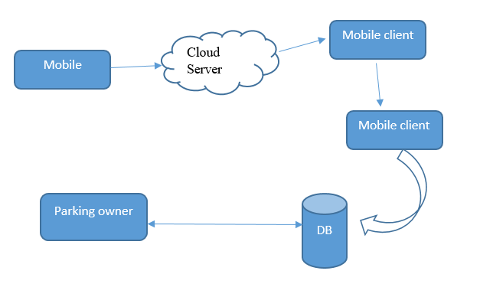

**SYSTEM REQUIREMENTS**

# H/W CONFIGURATION:

# Processor - I3/Intel Processor.

* RAM - 8GB (min).
* Hard Disk - 1 TB.
* Key Board - Standard Windows Keyboard.
* Mouse - Two or Three Button Mouse.

**S/W CONFIGURATION:**

* Operating System : Windows 7+.
* Programming : Java
* Server-side Script : Firebase
* IDE : Android Studio.
* SDK : Android
* Libraries Used : Volley, Material design.

**LEARNING OUTCOMES**

* About Android Studio.
* Android architecture.
* Basic about java.
* Basic about Firebase.
* Knowledge about server-side programming.
* Difference between client side and server-side programming language.
* Knowledge about server.
* Knowledge about database and queries.
* Knowledge about API.
* How to communicate with API.
* How API Communicate with Server.
* What are Packages and dependencies regarding the app?
* What are various versions of android app and android operating system?
* About Android studio.
* Client-side validation.
* Server-side validation.
* Difference between client-side validations.
* Different Debugging Technique’s.
* What is manifest?
* About XML.
* Widgets in android.
* Views in android.
* Layouts in android.
* How to design the user Interface.
* About activities.
* Recycler view formation.